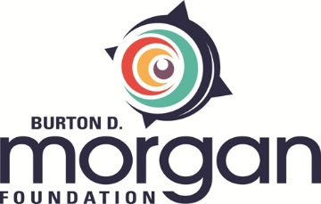

INTERIM GRANT REPORTING FORM

The purpose of this report is to help Foundation staff get a sense of your organization’s progress toward meeting grant objectives. Please email your completed form to Gina Dotson, Grants and Communications Manager, at gdotson@bdmorganfdn.org. You may use as much space as needed and/ or attach addenda.

Grant Number: Date Submitted:
(Assigned in grant award letter)

Grantee organization’s name:

Name and title of person submitting report:

Phone number and e-mail address of person submitting report:

NOTE: If this grant had a fiscal sponsor, please include a letter from the fiscal sponsor attesting to the report’s accuracy on outcomes and expenditures.

Requirements
Please refer to the Interim Grant Report Requirements outlined in the grant award letter and note them in the space below. Describe your progress on meeting these requirements and any impediments you have encountered along the way.

Discrepancies
If there is a discrepancy between the expected and actual activities of the grant, please provide an explanation, along with strategies for meeting grant expectations.

Grant Funds
Take a moment to compare the submitted project budget to the actual expenses to date. Identify any items of concern, including timeline for expenditure and line item updates.

Pivots
If the objectives, timeline, or budget for the grant need to be updated, a request must be made in writing that outlines any proposed changes. Funds must not be utilized for other purposes without approval from the President of the Foundation.

