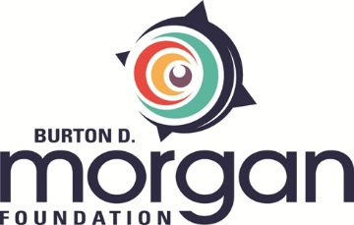

SPECIAL GRANTS REPORTING FORM

This report is to be completed after all grant dollars have been expended. Reports are evaluated on how well your organization meets grant objectives and contributes to the community.
Please email your completed form to Gina Dotson, Grants and Communications Manager, at gdotson@bdmorganfdn.org. You may use as much space as needed and/or attach addenda.

Grant Number: Date Submitted:
(Assigned in grant award letter)

Grantee organization’s name:

Name and title of person submitting report:

Phone number and e-mail address of person submitting report:

Activities
Describe the activities that were expected to take place as result of this grant (refer to your grant award letter), along with information on the outcome of each activity and participation figures, if applicable.

Learnings
Provide an overview of what was learned from this grant, how that information was shared with others (internally and externally), and how those findings will impact future programming.

Attachments
- Financial Summary
Please provide an itemized accounting of the grant funds, along with the complete income and expenses associated with the project.
- Media Coverage, if applicable
Attach a document that provides information on any media coverage related to the grant.

- Fiscal Sponsor Letter, if applicable
If this grant had a fiscal sponsor, please include a letter from the fiscal sponsor attesting to the report’s accuracy on outcomes and expenditures.

- Fiscal Sponsor Audit, if applicable
If this grant had a fiscal sponsor, please include the fiscal sponsor’s most recent audit.

